

Middle East Technical University

Electrical & Electronics Engineering Department

EE464 – Static Power Conversion II

Hardware Project

Simulation and Magnetic Design Report

Mehmet Hakan Yel - 2530699

Başak Koca - 2232304

Behtan Umut Mercan-2646974

Introduction

The present investigation concerns the design of an isolating converter. The initial step involves selecting a suitable topology, which is accomplished by verifying the desired ratings. The duty cycle and turns ratio is determined. The magnetic design of the transformer is then expounded upon in detail, taking into consideration the relevant properties. Subsequently, the process of component selection is elucidated about MOSFETs and diodes. Controller selection follows, as the project necessitates closed-loop, isolated control. Finally, the simulation is conducted, employing the calculated specifications in ideal case and in non-ideal case with the chosen components.

Problem Definition

The aim of this project is to implement an isolated DC-DC converter that takes variable input voltage between 12V and 18V and gives output voltage of 48V. It should be able to supply up to 48W power with voltage ripple less than 3%. The converter should have line and load regulation meaning that as the input voltage and output power varies, the output voltage should keep constant by means of feedback control.

Converter Topologies

***Flyback Converter***

A flyback converter is a type of DC-DC converter that uses a transformer to store energy during the on-time of the switching transistor and transfer it to the output during the off-time.

siyah, karanlık, ekran görüntüsü içeren bir resim

Açıklama otomatik olarak oluşturuldu

Fig. 1 Flyback Converter Topology

**Advantages**

Compared to other types of DC-DC converters, flyback converters have a simpler construction. They are simple to design and debug because of this.

The flyback converter is a low-cost choice for many applications due to its straightforward construction.

Galvanic isolation between the input and output is provided by flyback converters, which is helpful in situations that need for electrical separation.

Flyback converters are appropriate for use in situations where the input voltage may change because they can handle a large input voltage range.

It is simple to design the flyback converter to offer multiple outputs, which is helpful in some applications.

**Disadvantages**

Depending on the design and operating conditions, the flyback converter's efficiency is generally between 70% and 85% lower than that of other types of DC-DC converters.

Flyback converters that employ transformers might have considerable output ripple, which would not be acceptable for applications that need low noise levels.

Because of their low power efficiency, flyback converters might not be appropriate for high-power applications.

The flyback converter's cost and size may increase due to the transformer's potential size and weight.

To guarantee that the circuit performs correctly and effectively, the flyback converter has to be designed carefully. Inadequate design can lead to issues like decreased efficiency and greater output ripple.

***Forward Converter***

A forward converter is a type of DC-DC converter that uses a transformer to step down the input voltage to a lower voltage level.

diyagram, taslak, teknik çizim, plan içeren bir resim

Açıklama otomatik olarak oluşturuldu

Fig. 2 Forward Converter Topology

**Advantages**

Depending on the design and operating circumstances, forward converters can reach high efficacy levels, frequently in the region of 85% to 95%. Power is transmitted in both directions during each switching cycle, which is made possible by the employment of a transformer.

Since forward converters may be made to have a high-power density, they can be used in situations where there is a lack of available space.

Even in the presence of input voltage or load current changes, forward converters often offer strong regulation of the output voltage.

A forward converter is useful for applications that demand low noise levels due to its ability to decrease output ripple when using a transformer.

**Disadvantages**

Forward converters have a more sophisticated architecture than certain other DC-DC converter types, which can make designing and troubleshooting them more challenging.

Forward converters are frequently made for certain input and output voltage ranges, which might make them less flexible in various applications.

Forward converters have a high component count, which can raise their cost and complexity. They need more parts than certain other types of DC-DC converters.

Since a forward converter uses a transformer, the design may become heavier and more expensive as a result.

***Push-pull Converter***

A push-pull converter is a type of DC-DC converter that uses a center-tapped transformer to step up or step down the input voltage to a desired output voltage.

metin, diyagram, çizgi, plan içeren bir resim

Açıklama otomatik olarak oluşturuldu

Fig. 3 Push-pull Converter Topology

**Advantages**

Depending on the design and operating circumstances, push-pull converters can reach high levels of efficiency.

Push-pull converters offer strong output voltage control, even in the presence of input voltage or load current changes.

A push-pull converter is excellent for applications that call for low noise levels since it uses a center-tapped transformer to aid lower output ripple.

Push-pull converters function in a balanced way, which helps to cut down on noise and electromagnetic interference.

Push-pull converters are capable of handling high power levels, making them appropriate for applications requiring high power densities.

**Disadvantages**

Push-pull converters have a complicated architecture, which can make them more challenging to design and debug than certain other types of DC-DC converters.

Push-pull converters are often created for certain input and output voltage ranges, which might restrict their versatility in some applications.

A push-pull converter that uses a center-tapped transformer must include a magnetic component, which can increase the design's weight and cost.

Selection of components for the push-pull converter must be done carefully to ensure that the circuit functions properly and effectively. Reduced efficiency, higher EMI, and other issues can be brought on by improper component selection.

Overall, compared to the other topologies, the flyback converter appears to be more favorable in terms of implementation convenience, cost, and power range of our application.

Calculations

Choosing D = 0.4 is useful for most of the available controllers.

Rload is computed:

Capacitance is computed by using 3% output voltage ripple limit:

We can use a 10 μF capacitor to satisfy the inequality above, without large ripples.

Magnetic Design

Core

The core is selected as 00K3515E090 [1]. Our converter has high frequency with a small number of turns, which means the core losses are expected to be the dominant power dissipation component. E cores are better at radiating the core losses than toroid cores albeit worse at radiating the copper losses. Therefore, an E core with the smallest size in the stock is selected.

Turns Ratio and Magnetizing Inductance

If the duty cycle is assumed to be 0.4, switching frequency 100 kHz and efficiency 0.85, then

If turns are taken as , :

At which point,

In order to stay in CCM:

For CCM:

should be satisfied to be on the CCM. *Imavg* should be larger than 6.5A.As the turns ratio is 1/7*, ILOAD* and second winding of the transformer should be larger than 0.93A.

Wire Selection

Primary RMS current is calculated as,

No copper wire has the ampage of above this value and the maximum frequency for

100Se to these values are selected, which is 24 AWG.

Accordingly the fill factor is found as,

which is much smaller than 1.

DC resistance of the primary wire:

Core losses per volume per 100mT at 100kHz is given as .

As was expected, at such a high frequency, core losses are larger than copper losses and need E core to dissipate its heat. However, the optimum point of operation, where copper losses are equal to the core losses, can be achieved by decreasing the frequency.S

Test Results

Once the transformer is wound according to the proposed parameters, it is no-load and short-circuit tested from both sides and the results are the following:

Primary no-load test:

Primary short-circuit test:

Secondary no-load test:

Secondary short-circuit test:

Accordingly, transformer parameters are calculated as follows:

Apparently, leakage inductances are comparable with the magnetizing inductance due to windings being too far away from each other. This can be reduced by overlapping the windings on top of each other. Resistances are also measured to be much higher than calculated. The reason might be the proximity effect which is effective in high frequencies. This effect can be reduced by separating the turns of same side apart from each other

Simulation Results

diyagram, plan, metin, teknik çizim içeren bir resim

Açıklama otomatik olarak oluşturuldu

Fig. 4 Schematic of Flyback Converter for ideal case

metin, sayı, numara, diyagram, öykü gelişim çizgisi; kumpas; grafiğini çıkarma içeren bir resim

Açıklama otomatik olarak oluşturuldu

Fig. 5 Output voltage for Vin =12V.

metin, ekran görüntüsü, sayı, numara, yazı tipi içeren bir resim

Açıklama otomatik olarak oluşturuldu

Fig. 6 Output current for Vin =12V.

metin, sayı, numara, çizgi, diyagram içeren bir resim

Açıklama otomatik olarak oluşturulduFig. 7 Diode voltage for Vin =12V.

metin, diyagram, öykü gelişim çizgisi; kumpas; grafiğini çıkarma, çizgi içeren bir resim

Açıklama otomatik olarak oluşturuldu

Fig. 8 Diode current for Vin =12V.

metin, ekran görüntüsü, sayı, numara, çizgi içeren bir resim

Açıklama otomatik olarak oluşturuldu

Fig. 9 MOSFET voltage for Vin =12V.

metin, diyagram, çizgi, öykü gelişim çizgisi; kumpas; grafiğini çıkarma içeren bir resim

Açıklama otomatik olarak oluşturuldu

Fig. 10 MOSFET current for Vin =12V.

metin, ekran görüntüsü, yazı tipi, sayı, numara içeren bir resim

Açıklama otomatik olarak oluşturuldu

Fig. 11 Output voltage for Vin =18V.

metin, diyagram, çizgi, sayı, numara içeren bir resim

Açıklama otomatik olarak oluşturuldu

Fig. 12 Output current for Vin =18V.

metin, çizgi, diyagram, öykü gelişim çizgisi; kumpas; grafiğini çıkarma içeren bir resim

Açıklama otomatik olarak oluşturuldu

Fig. 13 Diode voltage for Vin =18V.

metin, yazı tipi, çizgi, sayı, numara içeren bir resim

Açıklama otomatik olarak oluşturuldu

Fig. 14 Diode current for Vin =18V.

metin, diyagram, çizgi, sayı, numara içeren bir resim

Açıklama otomatik olarak oluşturuldu

Fig. 15 MOSFET voltage for Vin =18V.

metin, diyagram, çizgi, öykü gelişim çizgisi; kumpas; grafiğini çıkarma içeren bir resim

Açıklama otomatik olarak oluşturuldu

Fig. 16 MOSFET current for Vin =18V.

**Mosfet Selection**

It is known that switching element must be withstand the maximum input voltage and the secondary voltage reflected value. On the other hand, spikes which are caused by leakage inductances should be considered. MOSFET VDS can be calculated from below formula: [1]

Where;

*estimated to be thirty percent of the*

1.3 additional safety factor

In order to be simulate more realistic, only the MOSFET's in the LTspice library are searched.

Si7852DP with VGS=80V and ID=6.1 A is chosen *just for the simulation*. It has low RDSon (16 mΩ)

Fig. 17 Mosfet Technical Data.

**Snubber Design**

Snubber design should be made otherwise voltage spikes may cause MOSFET breakdown. [2]

Maximum snubber capacitor voltage ripple is arranged as 10%.

Power in the snubber resistor can be estimated as follows:

**Circuit Simulation with Non Ideal Elements**

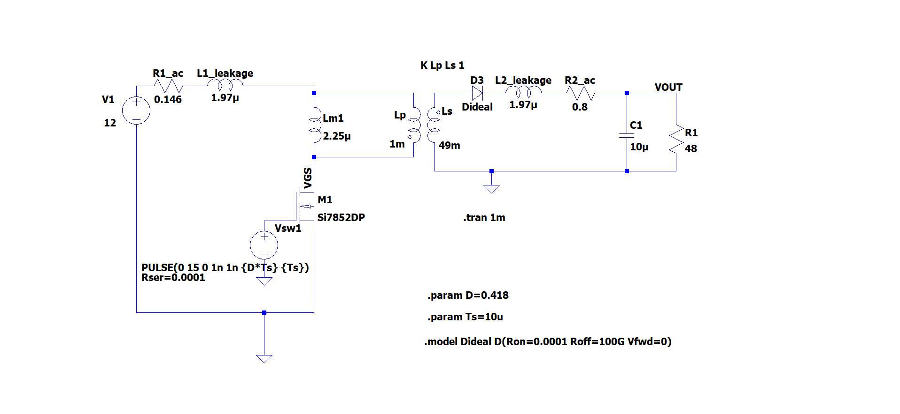

Fig. 18 Circuit Schematic with Non-Ideal Components

**VDS Voltage Without Snubber**

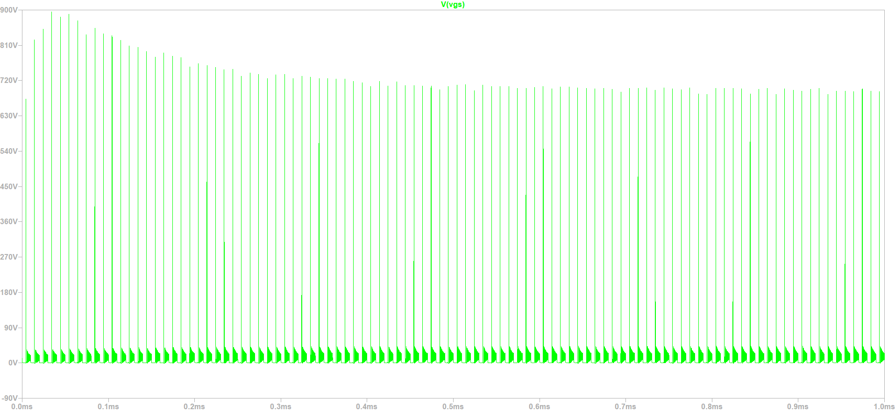

Fig. 19 MOSFET Drain-Source Voltage

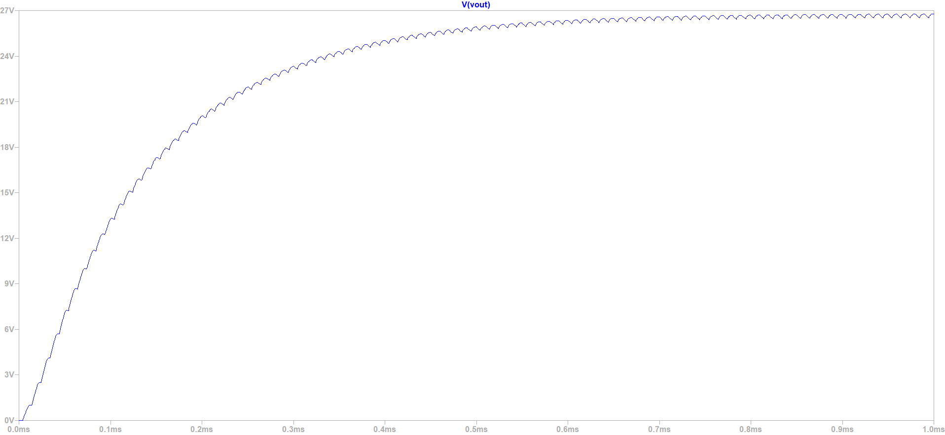

Fig. 20 Output Voltage

**VDS voltage with snubber**

Snubber circuit is added.

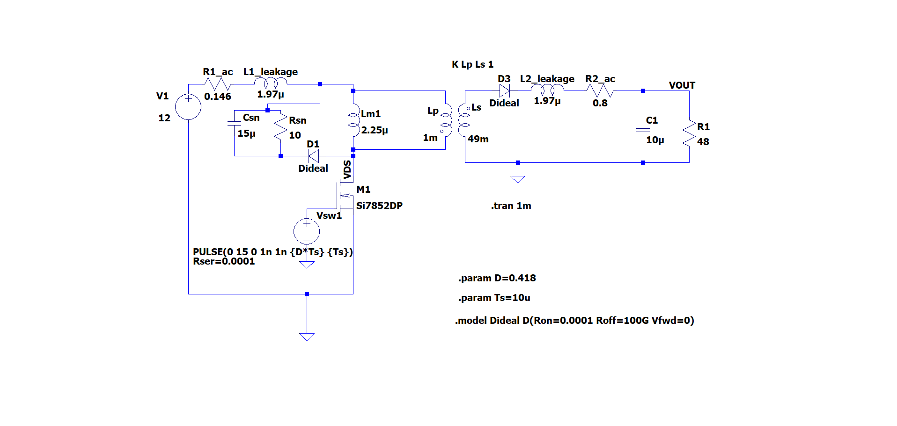

Fig. 21 Circuit Schematic with Snubber Circuit

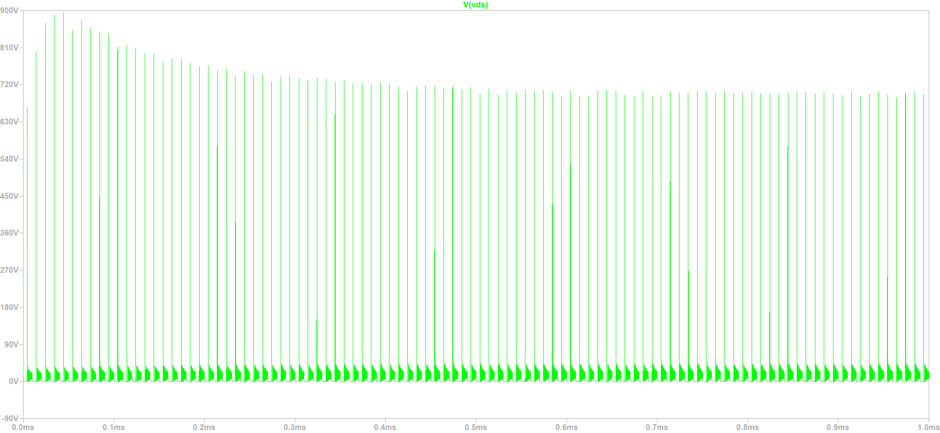

Fig. 22 MOSFET Drain-Source Voltage with Snubber Circuit

Circuit simulations has done again with assuming lower leakage inductance.

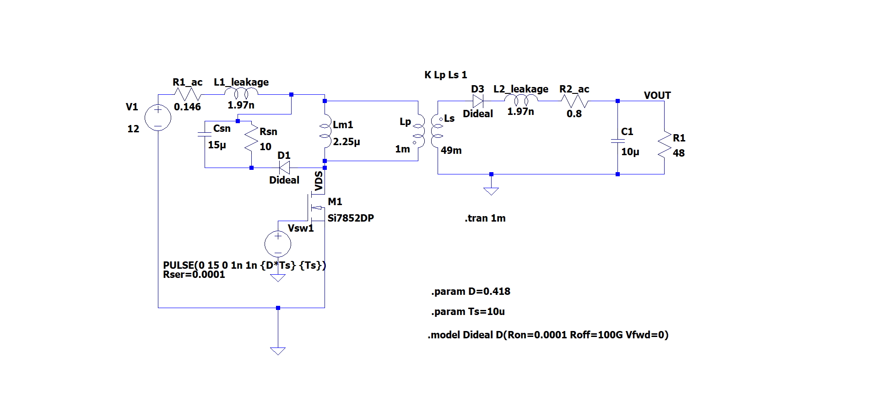

Fig. 23 Circuit Schematic with Snubber Circuit

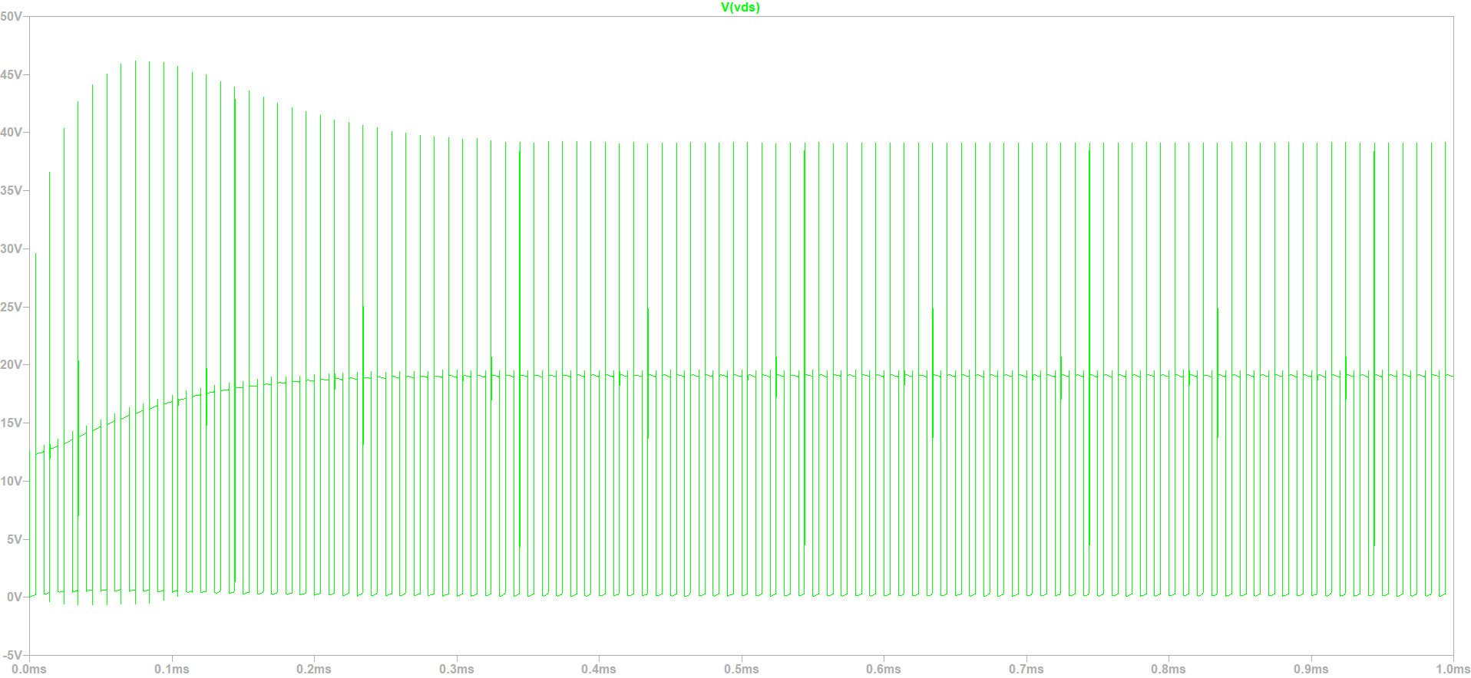

Fig. 24 MOSFET Drain-Source Voltage with Snubber Circuit

VDS (Drain to source) voltage is now reasonable value.

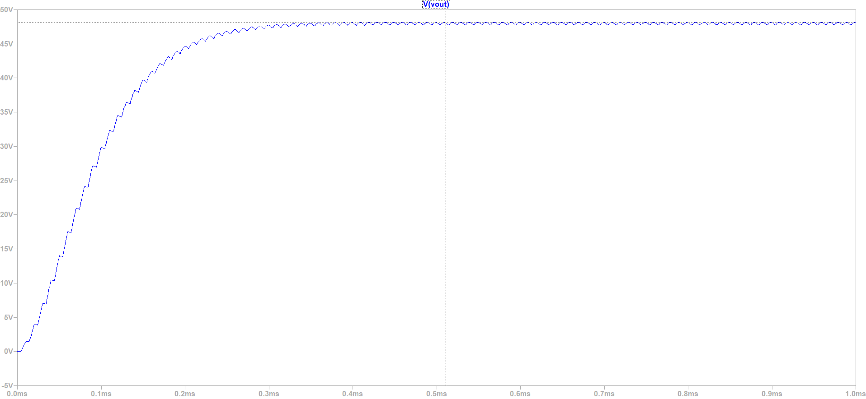

Fig. 25 Output Voltage with Snubber Circuit

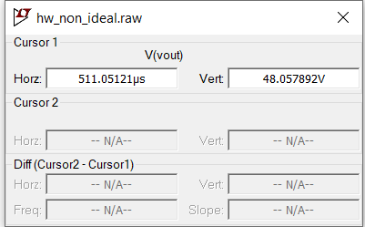

Fig. 26 Output Voltage Data

In order to get output voltage of 48 V duty cycle is set to a little bit higher than 0.4. The reason for that is non-idealities of the components. In order to be more safe the turns ratio should be considered again.

**Question F**

**%100 load:**

* **Losses of the transformer**

**Copper Losses**

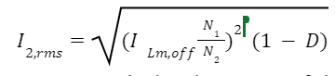

Copper losses are calculated as 1.26 W before.

**Core Losses**

Core losses are calculated as 5.32 W before.



* **Losses of Mosfet**

**Mosfet Conduction Losses**

In the on state, MOSFETs do not behave like an ideal switch with zero impedance, instead MOSFETs have a small resistor called . Due to this resistance, there are power losses in the mosfet and they are calculated as follows [3]:

**Mosfet Switching Losses**

In addition to the conduction losses, switching losses occur when the switches are opened and closed. Below figure shows the changes in the opening state and shows the changes in the closing state. In this case, the changes in voltage and current are assumed to be linear. The energy loss in a switching transition is the area under power. Since average power is energy divided by period, higher switching frequencies result in higher switching losses.

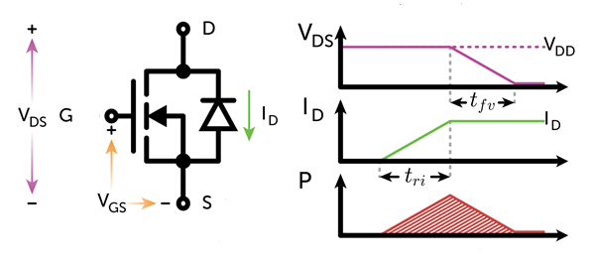

Fig. 27 MOSFET Switching Graph

Thevalue represents the current rise time and the value represents the voltage drop time on the graph in the trip state. Similarly, the value of in the graph in the closing state represents the decrease time of the current, and the value of refers to the decrease time of the voltage. The lost energy is found from the areas under the power graph and then the lost power is found by dividing it by the frequency.

( [3]

0.444 W

* **Diode Losses**

Diode losses can be calculated from below formula.

[4]

* **Inductance Conduction Losses**

The following formula is given to find the inductance conduction losses:

Inductance conduction loss;

The average value of the inductance current I_L is equal to the sum of the input current and output current. Therefore, the peak value of the switch current is reached.

[5]

**Efficiency Calculation**

Total losses can be calculated as follows:

Efficiency:

Components

**Switch Selection**

According to calculations, the MOSFET's maximum drain to source voltage is around 26V, and its maximum current is approximately 18A. According to calculations, the MOSFET's maximum drain to source voltage is around 26V, and its maximum current is approximately 18A.

We have chosen “STD20N20T4 TO-252 18A 200V 0.10Ω N-CHANNEL MOSFET” for this operation.

**Diode Selection**

Although the diode's maximum reverse voltage is 170 V and its current is 2.33 A, we may use a precaution and choose a 200 V, 5 A diode.

We have chosen “HER503 5A 200V THT Diode” for this purpose.

**Capacitor Selection**

A 10 uF capacitor is more than enough to reduce the voltage ripple above 3%.

Conclusion

In conclusion, it can be observed that flyback topology is acceptable due to its benefit of having fewer components and no restrictions on duty cycle. It also provides a selection of analog controllers. Magnetic design and design calculations were completed. It was done to simulate both ideal and non-ideal circuits using a snubber. The components were chosen to fit within the simulations' voltage and current constraints.

**References**

**1.** Dinwoodie, L. (1999). Design Review: Isolated 50 Watt Flyback Converter Using the UCC3809 Primary Side Controller and the UC3965 Precision Reference and Error Amplifier. Texas Instruments. Retrieved May 1, 2023, from https://www.ti.com/lit/an/slua086/slua086.pdf

**2.**How to design a flyback converter in seven steps: Article: Mps. Article | MPS. (n.d.). Retrieved May 4, 2023, from https://www.monolithicpower.com/how-to-design-a-flyback-converter-in-seven-steps

**3**.(2012),*Small Signal OptiMOS™ 606 MOSFET in Low Power DC/DC converters,*(Application Note, AN 2012-12,), Retrieved from Infineon Technologies website:https://www.infineon.com/dgdl/Infineon-MOSFET_OptiMOS_606_Small_Signal_MOSFET_in_low_power_DC-DC_converters-AN-v01_00-EN.pdf?fileId=db3a30433c1a8752013c39eca58b4ae4

**4.** Lopez, M., Morales, D., Vannier, J.-C., & Sadarnac, D. (2007). Influence of Power Converter Losses Evaluation in the Sizing of a Hybrid Renewable Energy System. 2007 International Conference on Clean Electrical Power, Clean Electrical Power, 2007. ICCEP ’07. International Conference On, 249–254. <https://0-doi-org.divit.library.itu.edu.tr/10.1109/ICCEP.2007.384218>

**5.**Hairik, H. A., AbdulAbass, A. K., & Abbas, K. A. (2019). DC/DC Buck-Boost Converter Efficiency and Power Dissipation Calculation at Operating Points Not Included in the Datasheet. Journal of Multidisciplinary Engineering Science and Technology (JMEST), 6(6).